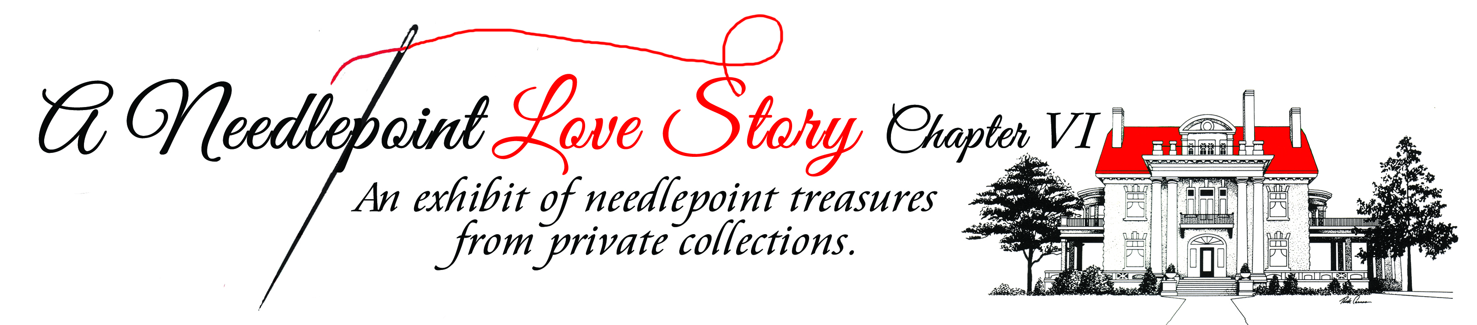
Contributors Information Form

Name: _____________________________ Tele.# ___________________
Mailing Address: _____________________________________________
Email Address: ______________________________________
Number of Items Exhibiting: ___________________________
Descriptions and Dimensions of Items:

Deliver labeled needlepoint (including designer’s name for each piece, if known) to Thistle Hill, 1509 Pennsylvania Avenue, 76104 on:

Sunday, February 17: 11:00 a.m. - 4:00 p.m.

Wednesday, February 20: Champagne Reception 5:00 p.m. – 7:00 p.m.

Thursday, February 21-Sunday, February 24: Exhibit Open to the Public

Tuesday, February 26: Pick up needlepoint from 10:00 a.m. – 5:00 p.m.
NO CARS ALLOWED ON THE DRIVEWAY UNTIL 2:30!

This Form Should be Emailed or Mailed or Faxed (817-336-2346)to:
suzy_coleman@historicfortworth.org
Historic Fort Worth, Inc. 1110 Penn Street, Fort Worth, Texas 76102

