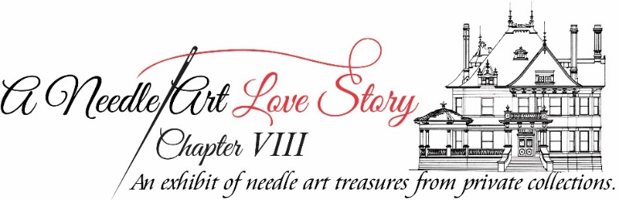

The Needle Art Committee would appreciate the donations of needle art items to be sold by Historic Fort Worth to be Loved by another needle art aficionado!

_____ I would like to donate a stitched and finished needle art piece/pieces.

____ I would like to donate a partially finished or unstitched piece/pieces.

Stitcher’s Name: ______________________________________________________

Email Address: _______________________________________________________

Contact Number: ______________________________________________________

Please deliver to McFarland House, 1110 Penn Street 76102 by May 28, 2021!

Description of the Item/Items (Please indicate if item is stitched and finished, partially finished, or an unstitched piece, and if yarns are included).

After receiving the donated item/items, Historic Fort Worth will issue you a tax donation form that you fill in the value for the item/items for your tax preparer!

