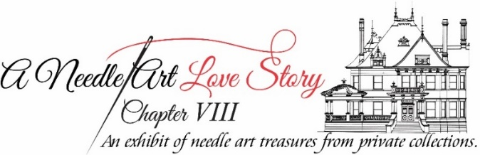
Contributor’s Information Form

Name: _____________________________ Tele.# ___________________
Mailing Address: _____________________________________________
Email Address: ______________________________________
Number of Items Exhibiting : __________ (Maximum 6 sets)*
Descriptions** (include designer’s name for each item/set, if known) and Sizes of Items/Sets:

Sizes (frame or footprint): Small (< 5x7) Medium (<11x14) Large (<20x24) XL: (>20x24)
*A set, like a Nativity or Noah’s ark, may include more than 1 piece. Please indicate the number of pieces in each set.
**Descriptions should indicate if the piece/set is Needlepoint or Cross Stitch, freestanding, easel back, framed, ornament, pillow, stocking, etc.

Deliver labeled needle art items to McFarland House, 1110 Penn Street, 76102 on:
Sunday, June 6: 11:00 a.m. - 4:00 p.m.

Event Details:
Wednesday, June 9: Party with the Stitchers 5:00 p.m. – 7:00 p.m.
Thursday, June 10-Sunday, June 13: Exhibit Open to the Public
Tuesday, June 15: Pick up needle art items from 10:00 a.m. – 5:00 p.m.

Due to the Change in Venue and Staging for the Exhibit, this form must be
RECEIVED (Email or Mail) by May 28, 2021 to:
suzy_coleman@historicfortworth.org
Historic Fort Worth, Inc. 1110 Penn Street, Fort Worth, Texas 76102

