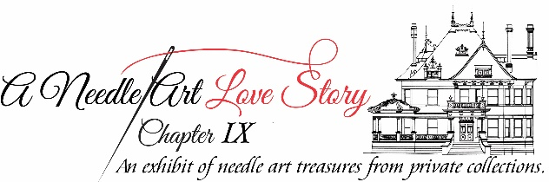

Exhibitor’s Information Form

Name: _____________________________ Tele. # ___________________
Mailing Address: _____________________________________________
Email Address: ______________________________________
Number of Items Exhibiting: __________
Descriptions* (include designer’s name for each item, if known) and Sizes of Items:

Sizes (frame or footprint): Small (< 5x7) Medium (<11x14) Large (<20x24) XL: (>20x24)
*Descriptions should indicate if the piece is Needlepoint or Cross Stitch, freestanding, easel back, framed, ornament, pillow, stocking, etc.
Deliver labeled needle art items to McFarland House, 1110 Penn Street, 76102 on:
Sunday, June 5: 11:00 a.m. - 4:00 p.m.

Event Details:
Wednesday, June 8: Party with the Stitchers 5:00 p.m. – 7:00 p.m.
Thursday, June 9 - Sunday, June 12: Exhibit Open to the Public
Tuesday, June 14: Pick up needle art items from 10:00 a.m. – 5:00 p.m.

Due to the size of the Venue and Staging for the Exhibit, this form must be
RECEIVED (Email or Mail) by May 27, 2021 to: NeedleArtLoveStoryCVB@gmail.com

Historic Fort Worth, Inc. 1110 Penn Street, Fort Worth, Texas 76102

